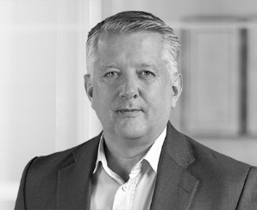

Curriculum vitae for George Burn
George Burn FCIArb is the Global Co-Leader of the International Arbitration Practice at BCLP. He is a specialist in investor-state and international commercial arbitration, with over 25 years’ experience of acting as arbitrator and counsel in complex, high-stakes disputes.
George has acted for companies, state-owned entities and individuals, and sat as arbitrator, in disputes in multiple sectors, including: infrastructure, engineering, energy, banking, construction, technology, mining, defence, real estate development, and trade. Most of the arbitrations on which George has worked have been seated in London but he has also been active in seats around the world. The disputes on which he has worked have been conducted under a wide range of arbitral rules: LCIA, ICC, UNCITRAL, SCC, CIArb, ICSID, SIAC, HKIAC, DIS, AAA-ICDR, PCA, CRCICA and AFSA.
George has been active in the arbitration community, having served on ICC task forces and on the ICC UK National Committee, as well as the SIAC Users’ Council and in the LCIA. He has written and lectured on a wide range of arbitral topics. He is recognised as a leading specialist in the principal professional directories.
Professional history:
2017-date: Partner BCLP
2013-2017: Partner Vinson & Elkins
2007-2013: Partner Salans (now part of Dentons)
1997: Qualified as a solicitor
Academic history:
1992-1994: College of Law – Diplomas in Law and Legal Practice
1988-1992: University of Leeds – BA Hons in Politics and Parliamentary Studies

George Burn
Partner, BCLP
T: +44 7958 588325
george.burn@bclplaw.com

