CIArb London Branch – Election Manifesto 2026
Professor Eur Ing Dr Phebe Mann FCIArb
Candidate for: CIArb London Branch Committee Member

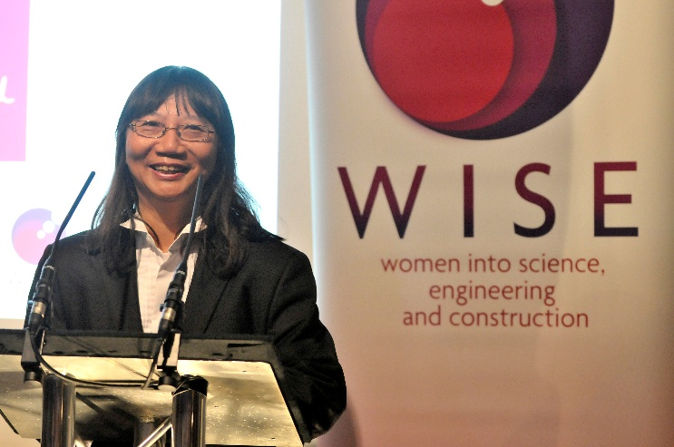
Dear Members of the CIArb London Branch,
I am honoured to present my candidacy for election to the CIArb London Branch Committee. I am a Fellow of the Chartered Institute of Arbitrators (FCIArb) with extensive experience across arbitration, adjudication, mediation, judicial service, academia, and professional governance, both in the UK and internationally.
Having served for many years in senior leadership roles across the legal profession, higher education, engineering, construction, and dispute resolution, I am deeply committed to advancing CIArb’s mission, accessibility, and professional excellence, particularly within the London Branch.

My Priorities
1. Supporting Members Across Disciplines and Career Stages
I am committed to ensuring that the London Branch actively supports arbitrators, adjudicators, mediators, academics, tribunal members, engineers, surveyors, and legal practitioners. Drawing on my experience as a Specialist Tribunal Member in the Upper Tribunal and First-tier Tribunal, I understand the importance of accessible, practical, and inclusive professional engagement.
I am trusted to be an approachable committee member, ensuring that members’ concerns and ideas are heard, supported, and effectively progressed.

2. Strengthening Education, Training, and Professional Development
As a Visiting Professor, former Senior Lecturer, Examiner, and programme director, I have led curriculum design and professional training across arbitration, adjudication, construction law, and ADR for decades.
I would support:
- High-quality CPD events across arbitration, adjudication, mediation, and hybrid dispute resolution
- Practitioner-focused masterclasses linking law, engineering, and construction disputes
https://www.linkedin.com/posts/dr-hector-martin-phd-fhea-masce-reng-pmp-ceng-mice-126488141_mediation-as-alternative-dispute-resolution-activity-7419013899892465664-tXu4?utm_source=share&utm_medium=member_android&rcm=ACoAAEegPm4B0qxrpdm8mdb19k560ead7mGbkcU
- Events supporting early-career professionals and cross-disciplinary entrants to ADR
3. Promoting Innovation, Technology, and Modern Dispute Resolution
My academic research and professional practice have consistently focused on innovation, digital learning, and modern dispute resolution methods, including blended and online models.
I would encourage the Branch to:
- Explore technology-enabled ADR
- Engage with developments in online dispute resolution
- Support dialogue between academia, practitioners, and industry

4. Diversity, Inclusion, and Cross-Disciplinary Engagement
As an award-winning educator and long-standing advocate for widening participation, diversity, and inclusion, I am committed to ensuring CIArb continues to reflect the breadth of its membership and professions.
I would support initiatives that:
- Encourage participation from underrepresented groups
- Strengthen links between law, engineering, construction, and surveying professionals
- Promote inclusive access to CIArb events and leadership
Conclusion
I am passionate about serving the CIArb London Branch with integrity, energy, and professionalism. I bring a unique cross-disciplinary perspective, combining judicial experience, academic leadership, professional governance, and ADR practice.
I would be honoured to have your support and your vote.
Yours sincerely,
Professor Eur Ing Dr Phebe Mann FCIArb
MA(Cantab) MSc PhD LLB DipICArb LLM
CEng MICE MCIOB CIHM MCILEX FRICS FCIArb FRSA FHEA
Curriculum Vitae
Professor Eur Ing Dr Phebe Mann FCIArb
MA(Cantab) MSc PhD LLB DipICArb LLM
CEng MICE MCIOB CIHM MCILEX FRICS FCIArb FRSA FHEA
Professional Profile
Professor Eur Ing Dr Phebe Mann is a Fellow of the Chartered Institute of Arbitrators (FCIArb) with extensive experience in arbitration, adjudication, mediation, tribunal work, academia, and professional leadership. She has served in senior roles across the legal, engineering, construction, and higher education sectors, and has been widely recognised for excellence in teaching, research, innovation, and professional service.
She is a Specialist Tribunal Member in the Upper Tribunal Administrative Appeals Chamber and First-tier Tribunal, and a Visiting Professor of Construction Law, Management and Engineering.
Education and Qualifications
- Bar Professional Training Course, City Law School, City, University of London
Called to the Bar at Lincoln’s Inn (2020)
- Postgraduate Diploma Legal Practice LPC, De Montfort University
- LLM Construction Law, Arbitration and Adjudication, Robert Gordon University
- Postgraduate Diploma in International Commercial Arbitration, Chartered Institute of Arbitrators, Jesus College, Oxford
- LLB (Hons), University of Buckingham
- PhD, The Open University (Educational Technology) - Phi Delta Kappa Outstanding Doctoral Dissertation Award
- Postgraduate Diploma, Interdisciplinary Design for the Built Environment, Cambridge University, QUEST Award, Institution of Civil Engineers
- MA (Cantab) Computer Science, University of Cambridge
- MSc Bridge Engineering, University of Surrey
- MSc Construction Management, Loughborough University,
Foreign and Commonwealth Office Award
Professional Memberships and Status
- FCIArb, Chartered Institute of Arbitrators
- FRICS, Royal Institution of Chartered Surveyors
- CEng MICE, Chartered Civil Engineer
- MCIOB, Chartered Construction Manager
- ADR Group Accredited Mediator
- MCILEx, Chartered Institute of Legal Executives

Judicial and Tribunal Appointments
Specialist Expert Member
- Agricultural Land Tribunal (Wales)
- Upper Tribunal, Administrative Appeals Chamber (Transport) https://judicialappointments.gov.uk/case-study/dr-phebe-mann-upper-tribunal-specialist-member-transport-jurisdiction-administrative-appeals-chamber/
- First-tier Tribunal, General Regulatory Chamber (Transport, Information Rights, Estate Agents)
- First-tier Tribunal, Tax Chamber

Academic and Professional Experience
Visiting Professor of Construction Law, Management and Engineering, Loughborough University
https://www.lboro.ac.uk/departments/abce/staff/phebe-mann/#tab5
- Senior Lecturer (Construction Law / Legal Framework), University of Westminster
- Senior Lecturer, University of East London, University of Reading
https://pages.cdn.pagesuite.com/b/7/b72c4cc5-ae6a-4ccb-827c-5b129e2c2589/page.pdf
- Associate Lecturer, Examiner, and Programme Director, University of Built Environment, Reading and The Open University

Honours and Awards (Selected)
- Telegraph / WES Top 50 Women in Engineering Award
Honorary Fellow, Bradford College page 46 https://greendaleconstruction.com/wp-content/uploads/2014/01/feb_14_cm_magazine.pdf
Dr Phebe Mann seen as role model for female Bradford students
https://www.thetelegraphandargus.co.uk/educationnews/education_news/15001583.Portrait_of_top_engineer_donated_to_Bradford_College_to__inspire__female_pupils/
- WISE / UKRC Woman of Outstanding Achievement Award
- Fellow, Royal Society of Arts
- Fellow, Higher Education Academy
- The Open University Practice-based Professional Learning (PBPL) Teaching & Learning Excellence Award
- Chartered Institute of Building International Innovation and Research Award

Selected Publications
- Construction Adjudicators’ Jurisdiction (2018)
- Worship in Cyber Church (multiple volumes, 2020–2024)
- Numerous peer-reviewed publications in construction law, ADR, and legal education
Languages
- English
- French
- Chinese

